Second Step SEL Curriculum
In Lessons 21, “Values and Relationships” and 22, “Recognizing Others’ Perspectives” of Unit 4 for the eighth grade, students are recommended to visit the website, “Love is Respect” at loveisrespect.org. The teachers are instructed to tell the students that they can get advice and support from this site. The site is reference in the teacher’s Learning Plan, in the Student Handout, and in one slide of the actual lesson.
Accessing the LoveisRespect website immediately brings up a pop-up window letting students know that on-line history can be tracked and advising them how to clear their browser history.
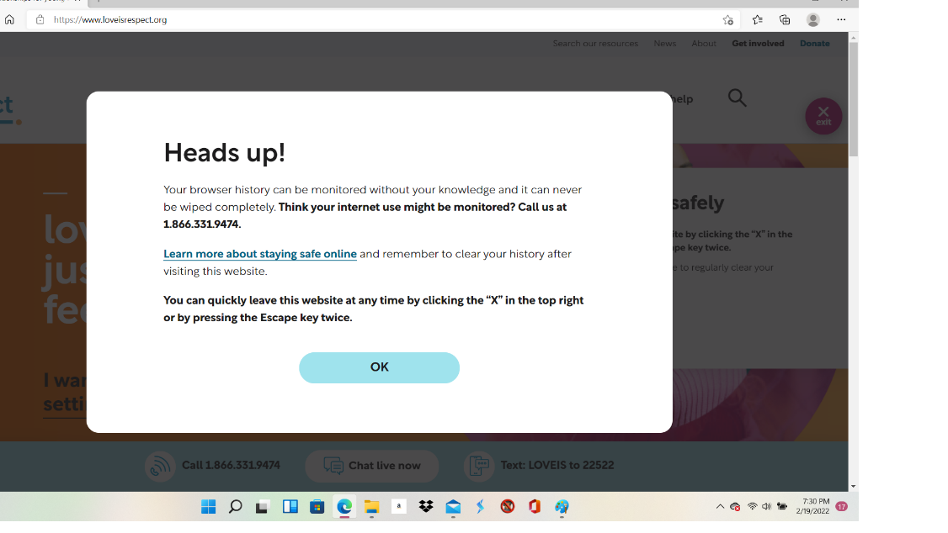

While navigating the site, a pop-up reminder constantly reappears to remind students to clear their browsing history.
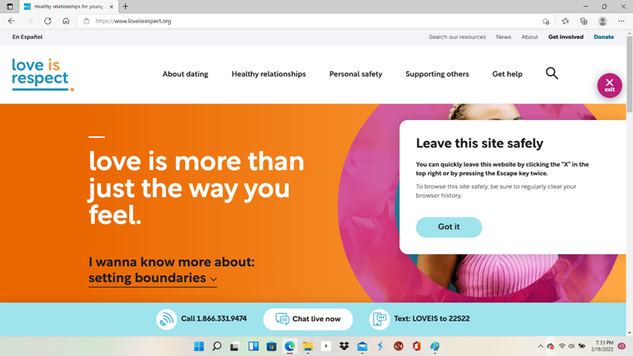

Throughout numerous sections in the LoveisRespect site, there are recommendations to the site, Scarleteen.com. and a live link is provided for students to immediately navigate to that site.

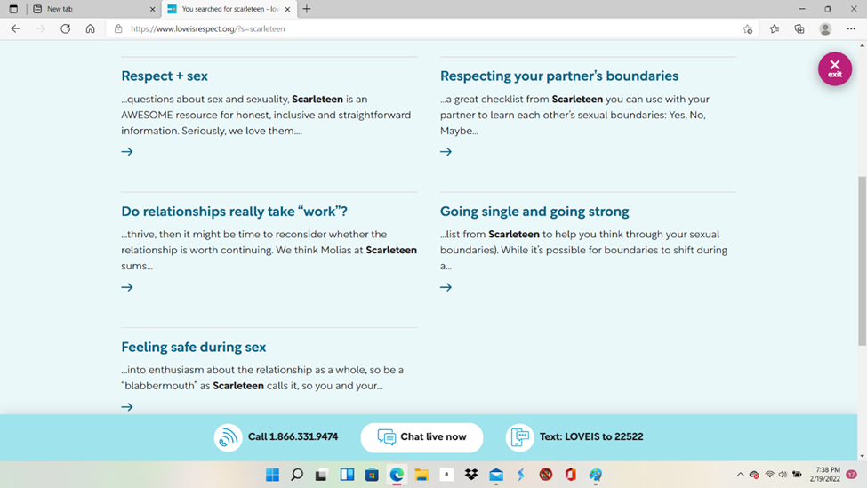
Scarleteen provides large amounts of information and material that is questionable and highly inappropriate for all minors, including middle school students. Lest there be any doubt in one’s mind, consider that the very NAME of this website is “Scarleteen,” so it is absolutely targeted to TEENS.
Using the search bar in Scarleteen and simply typing in the word, “abortion,” brings up several options, including “How to Access a Safe, Self-Managed Medical Abortion.”
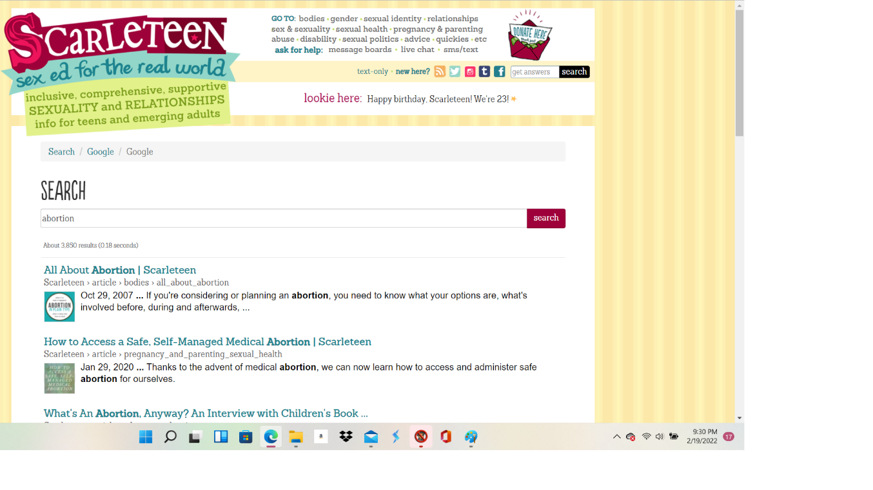
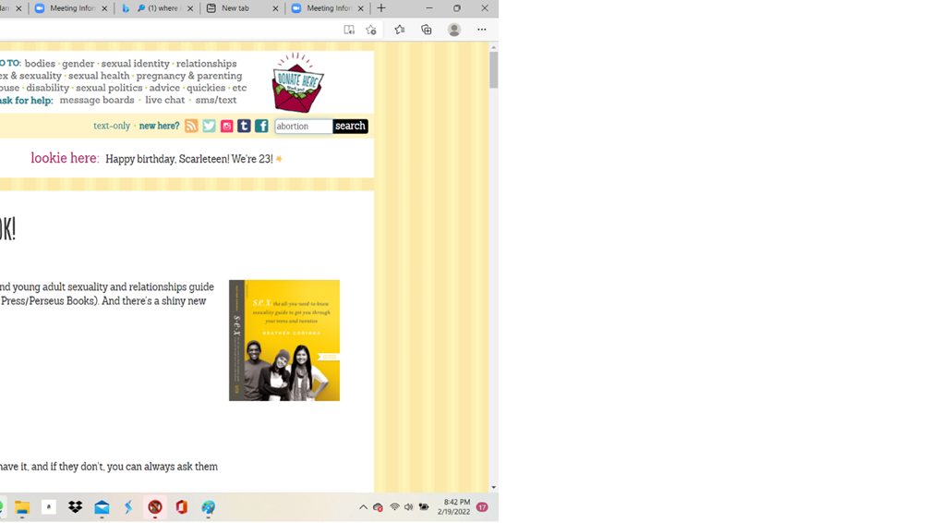

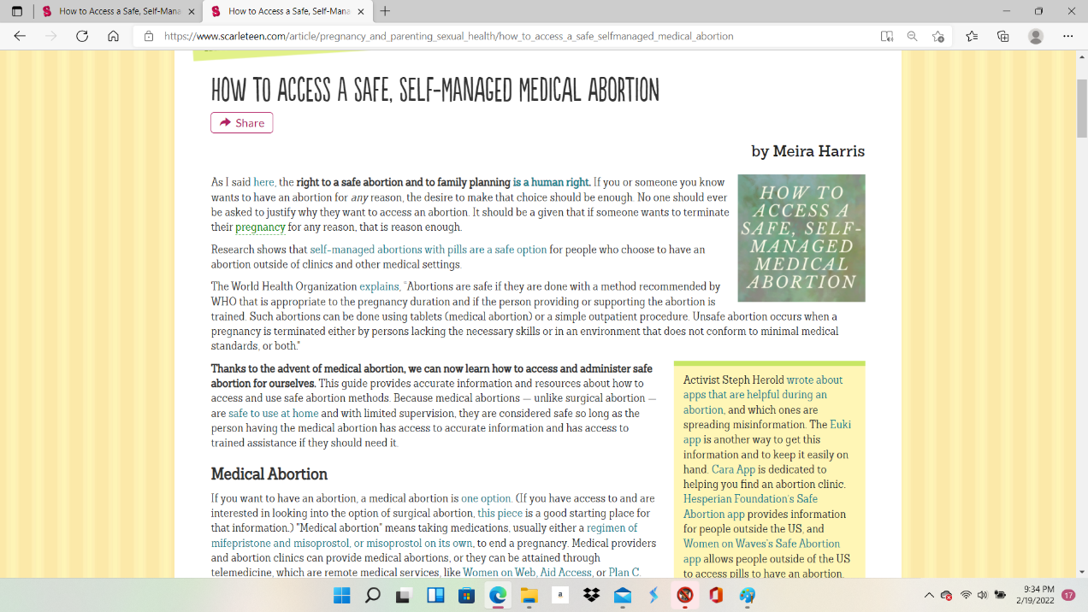
Upon clicking on the link for “How to Access a Safe, Self-Managed Medical Abortion,” several pages of very detailed how-to instructions appear. One of the first things the teens are told is that abortion is a “human right,” and that abortions are “safe.”

The instructions provide the specific names of the drugs required for a “self-managed” abortion, and even go so far as to instruct the teens (“We strongly advise you…”) to take the pills under their tongues should they require hospitalization so that NO evidence is there to show that they have attempted an abortion. In other words, the advice here is to deceive the medical staff who may need to know the facts of the situation. One can speculate that advice to deceive the medical staff would also imply deception of parents, as well.
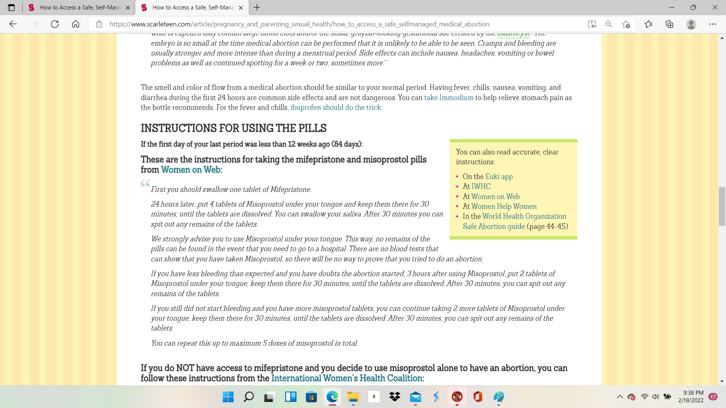

Scarleteen even goes so far as to prepare their reader for the possibility of a serious emergency in what they are labeling as a “safe” procedure and provide “Warning Signs.”

Scarleteen also provides “Warning Signs” for the “safe” abortion they are advocating.
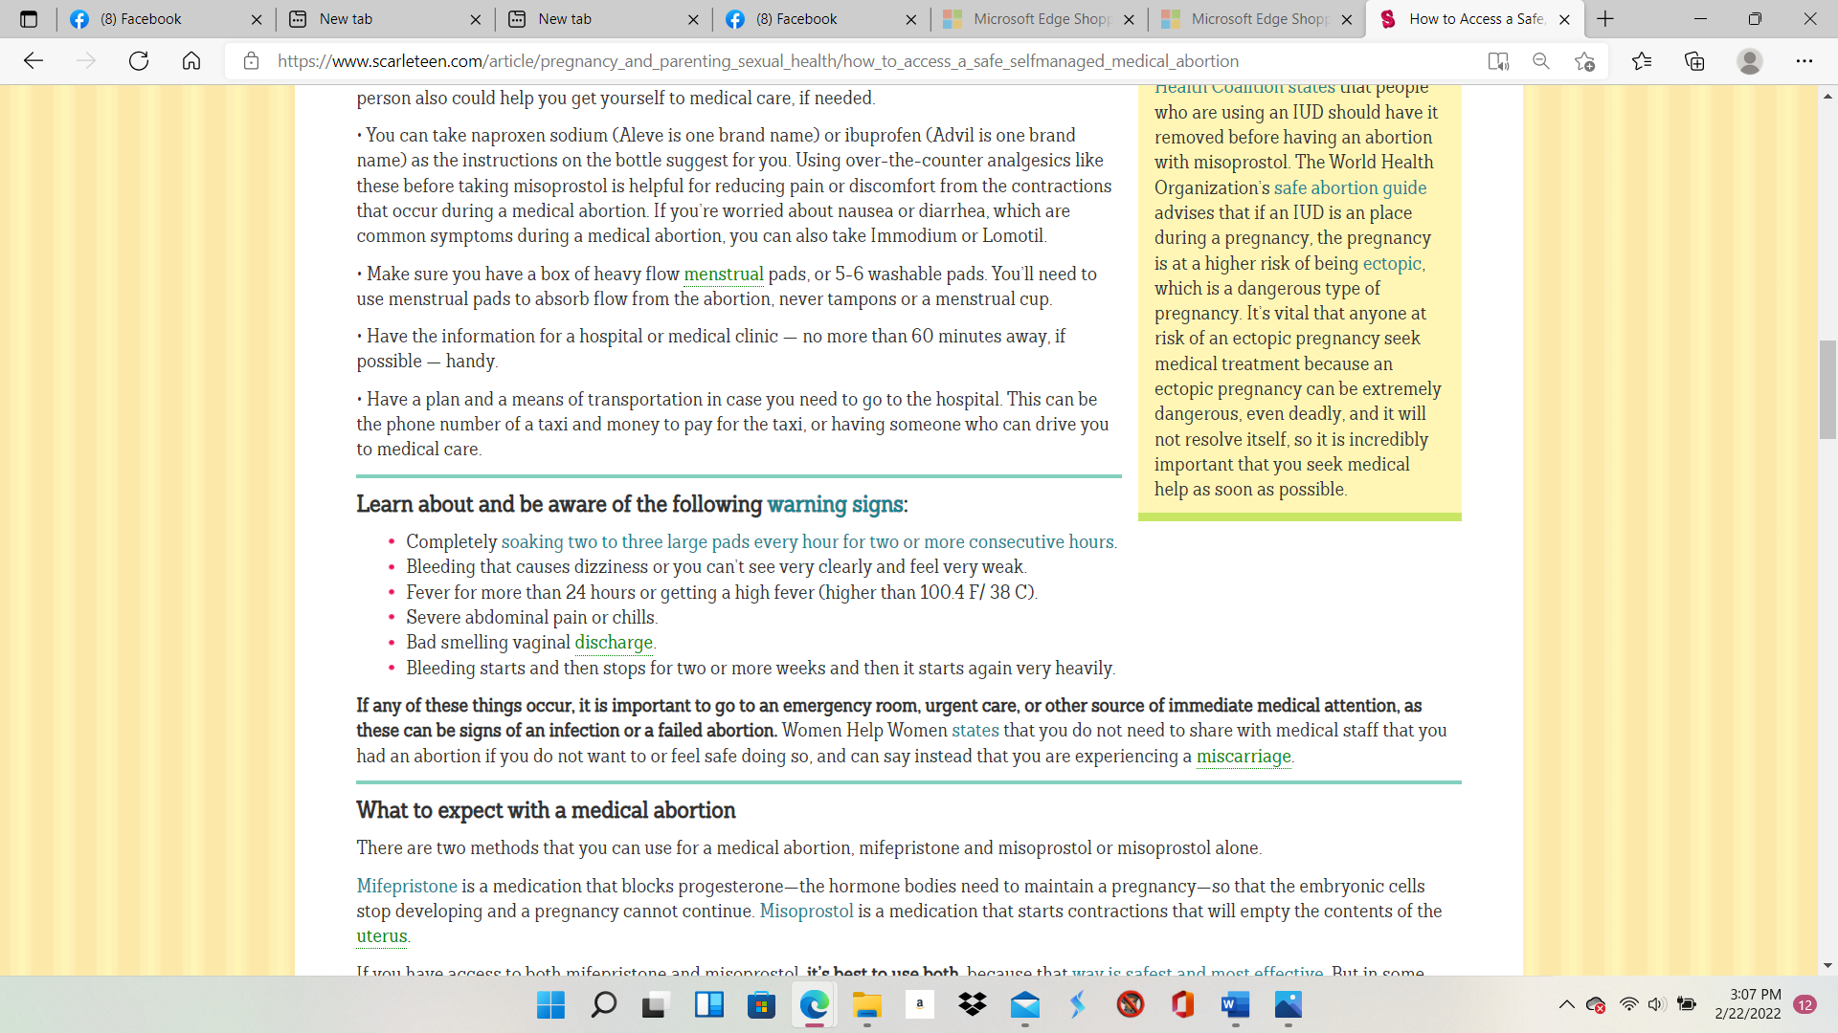

Not only does the Scarleteen site provide detailed instructions, but they also link to a number of websites all, presumably, giving similar advice and instructions, including the recommendation of a “fantastic” site called Jewish Currents. It’s important to note that under “Finding Support, the first piece of advice is to “listen to yourself…” or to go to one of the organizations listed (including Jewish Currents) on the Scarleteen website or even Scarleteen itself.
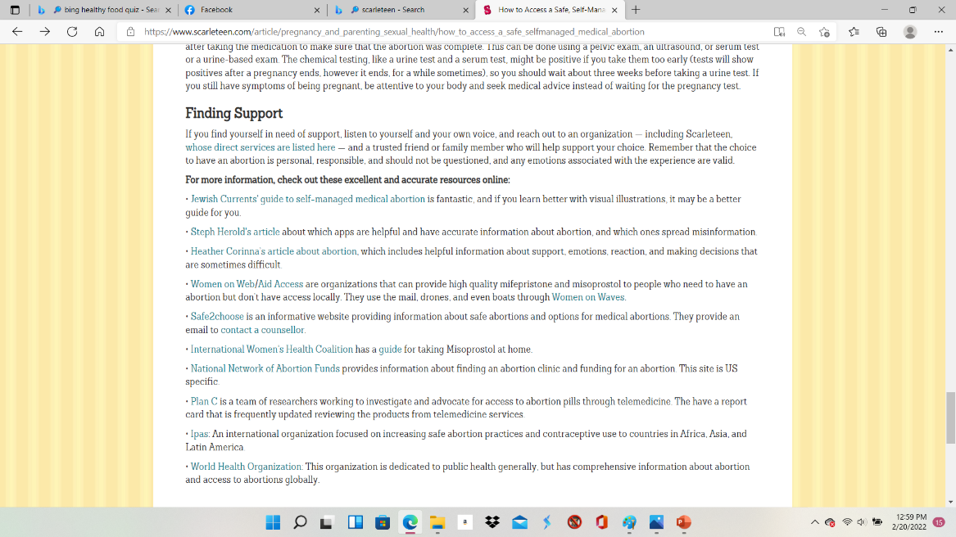

The Jewish Currents site also give detailed instructions on how to do a self-managed abortion. Using cartoon drawings, it seems clear that the material is geared towards very young people.
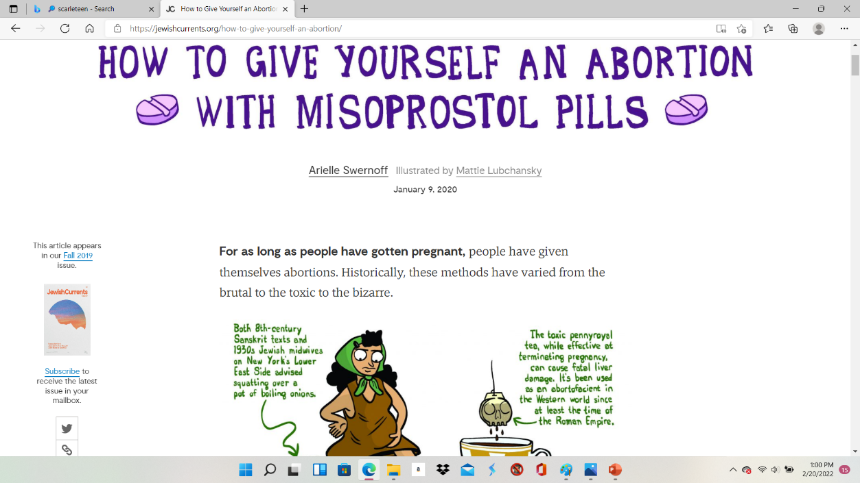

The Jewish Currents site (jewishcurrents.org) even offers three ways to obtain the abortion drugs, including going to a veterinarian, as one of the drugs is a common drug used for treating ulcers in dogs.

Jewish Currents instructs readers they can obtain the abortion drugs in three ways:
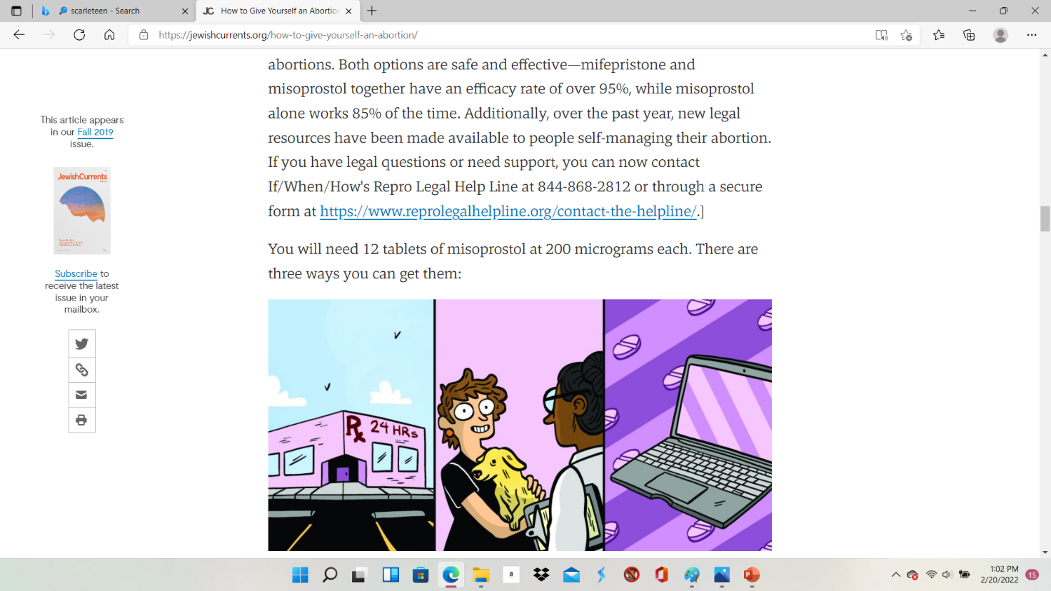

In person, through a veterinarian, and online.
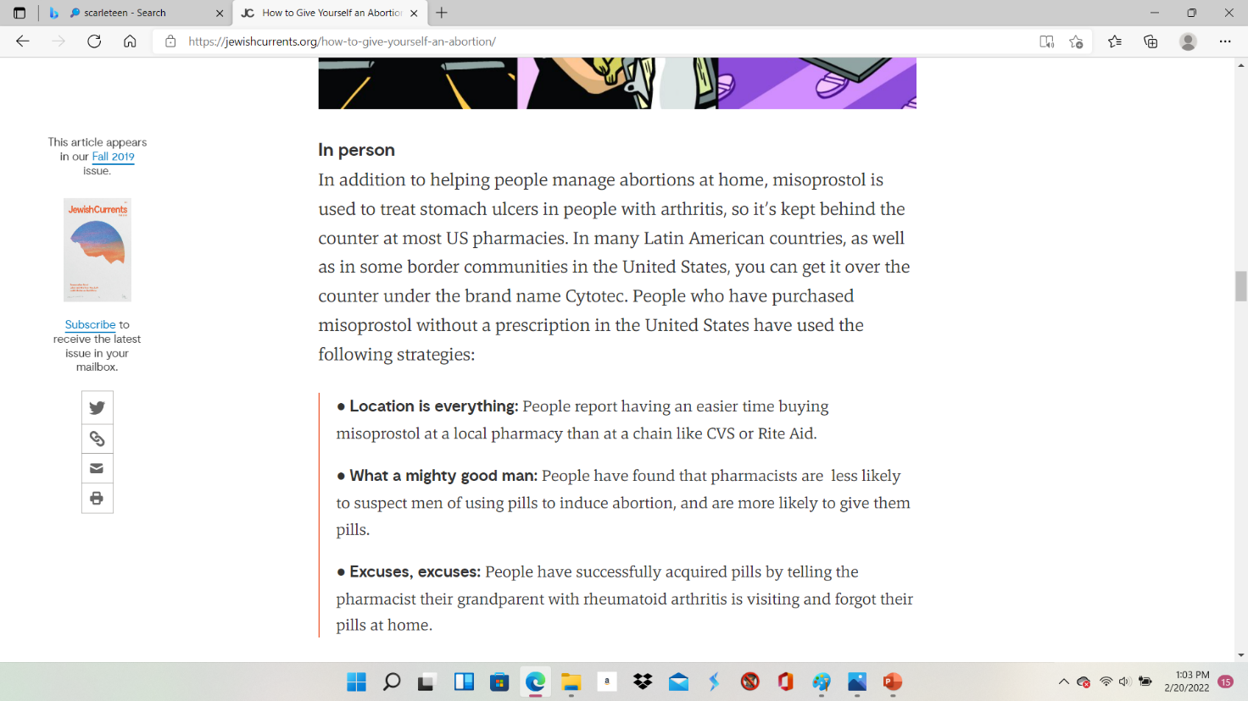
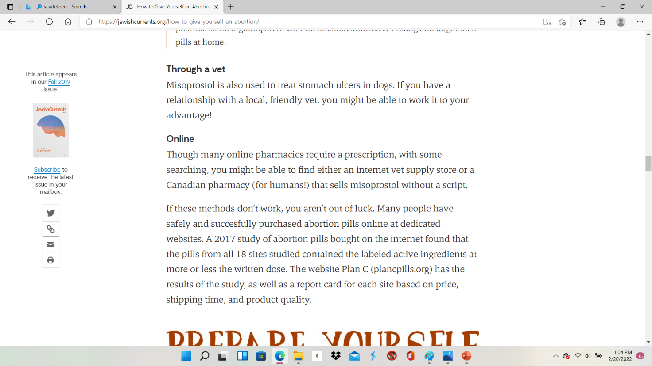

*Other disturbing information under the abortion search on the Scarleteen site brought up the following article on the need for teen access to abortion, including the idea that minors should not need parental permission to obtain an abortion, because in most states it is “legal” for them to “have sexual intercourse.
